DISCOVERY
  - IS THE BEGINNING OF KNOWLEDGE
Imagine a machine that understands your interests. The machine has read and stored facts from web sites you trust and linked them to topics that interest you. Your interests determines the facts you find, not other people’s words. This is the new age of knowledge discovery where you can truly say “I know it.”
  - Introducing iKNOWit
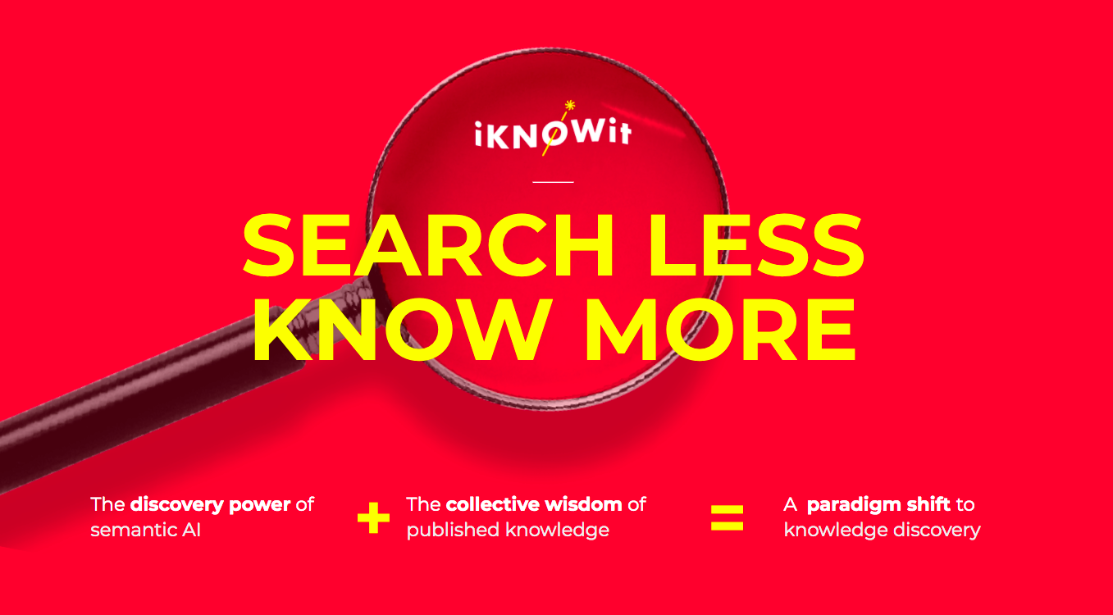
  - LET’S GO ON A QUICK DISCOVERY JOURNEY
I am planning to travel to China and want to know more about places to visit. I use iKNOWit to find facts about travel and tourist attractions in China. My discovery journey has three parts:
(1) a knowledge hub to help me understand context,
(2) a topic description to explain meaning to me of topics, and
(3) the facts I need to stay connected.
The knowledge hub starts me on a discovery journey by presenting specific discovery paths to follow like Tourism or Chemistry. I can browse by selecting topics of interest or explore by entering a few words describing my interests. The knowledge hub helps me understand the context of the facts I will find at the end of my discovery journey.
Tourism
 | - Tourism by country | - Tourism in China | - Tourist attractions in China | - Lakes of China
Chemistry
 | - Solid-state chemistry | - Salts  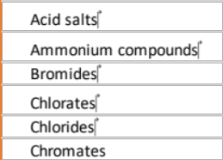 | - Saline lakes | - Saline lakes of Asia  Xiechi Lake
Knowing context helps me understand what I am reading. Every knowledge hub is a place to learn and explore by simply selecting a journey step like “Salts.” The pull down opens new related topics like “Bromides” as a type of Salts. By using iKNOWit I now understand more. I now know that Xiechi Lake is a tourist attraction, a saline lake, and a source of salts. Other broad topics leading to Xiechi Lake include Hydrology, and Limnology, the study of lakes and other bodies of fresh water.
The topic description is a link to a trusted reference source describing the topic in detail. I can see a quick summary of information about Xiechi Lake using the topic description.
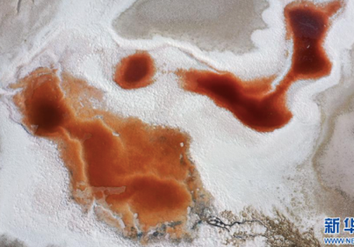
Xiechi Lake (Chinese: 解池): https://en.wikipedia.org/wiki/Xiechi_Lake
Xiechi Lake (Chinese: 解池), also called Yuncheng yanchi (Yuncheng Salt Lake) is the largest natural lake in Shanxi in Northern China. It is a saline lake[1] used for production of salt.
Every topic has a fixed image that is displayed. Over 5 million images are used to represent an interest. The image feature promotes recognition of common knowledge and understanding that is independent of language.

The facts are sentences posted from trusted web sources verified by iKNOWit. In search the usual result is a list of links to web sites not the facts inside them. Search users must open each web link and skim a web page to pick out relevant information. In iKNOWit all the web sites with relevant facts about the topic are presented in one place. Each article post relates to the topic I am interested in. My interests and results are not tracked outside iKNOWit. I personally control how my data is used. Best of all the facts that are discovered require far less time to skim than opening many sites in a browser. I am searching less while knowing more. There are often many posts. Here are two that showed up in my journey. The first is about the colors of the lake and the second about the science

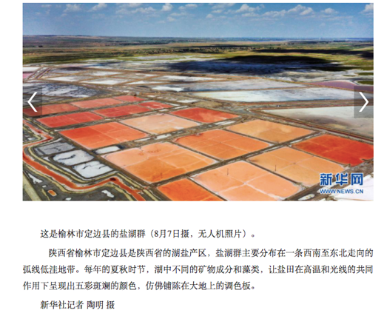
Beijing Youth Daily
http://news.ynet.com/2021/08/08/3343588t70.html
Dingbian County, Yulin City, Shaanxi Province is the lake salt producing area of ​​Shaanxi Province. In the summer and autumn seasons of each year, the different mineral compositions and algae in the lake make the salt pans show colorful colors under the combined action of high temperature and light, like a palette laid out on the earth

The next post is from the New Scientist about the science of Xiechi lake:
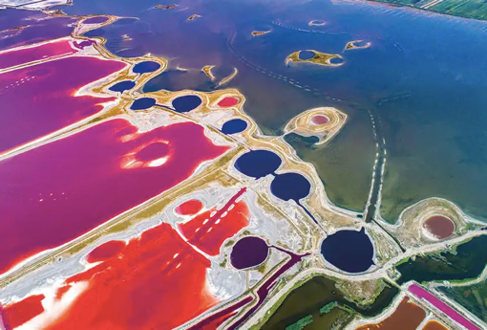
New Scientist
https://www.newscientist.com/article/mg23931932-400-chinas-spectacular-rainbow-lake-disguises-trouble-below-the-surface/
Yuncheng Salt Lake in Shanxi, northern China, D. salina is exposed to intense light and heat every summer. Combined with the lake’s high salinity, this supercharges its metabolism, causing it to produce large amounts of harmful, oxidising free radicals as byproducts. …Select a topic to explore this article:

Topic Tags:

Northern China
Eukaryotic
cells
Carotenoids
Salt

Each article can be explored more deeply using the topic tag feature, Every post shows you all the topics in the article. Selecting a topic tag leads to the same article but a different set of facts.

My journey has just begun but in the few minutes since I started, I have entered into an endless journey to know more . iKNOWit is the next generation discovery engine. Learn more https://iknowit.world/
Contact: George Burch george@iknowit.world
LinkedIn: iKNOWit

